Some General Resources on Brandom’s Philosophy of Language and Logic

Brandom by Ronald Loeffler
Key Contemporary Thinkers
Polity (Imprint of Wiley); 1 edition (December 26, 2017)
ISBN-13: 978-0745664200
ISBN-10: 0745664202

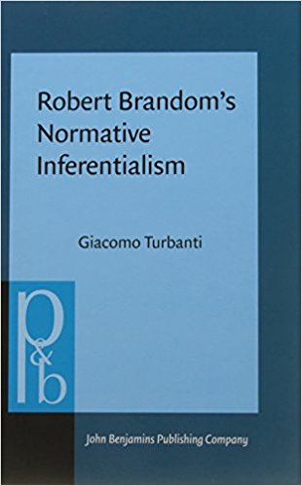

Robert Brandom’s Normative Inferentialism, by Giacomo Turbanti
Pragmatics & Beyond New Series (Book 280)
John Benjamins Publishing Company (September 21, 2017)
ISBN-13: 978-9027256850
ISBN-10: 9027256853
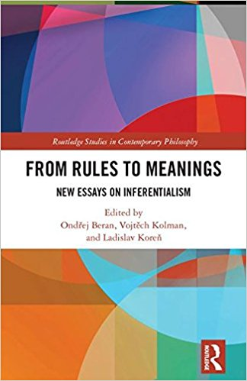
Ondrej Beran, Vojtech Kolman, Ladislav Koren (eds.) From Rules to Meaning: New Essays on Inferentialism (Routledge Studies in Contemporary Philosophy) 2018.
ISBN-13: 978-1138102613
ISBN-10: 113810261X

Hardcover: 288 pages
Publisher: Palgrave Macmillan; 2014 edition (October 6, 2014)
Language: English
ISBN-10: 1137452951
ISBN-13: 978-1137452955

